PROVINCIAL PRAYER DIARY
JANUARY2025– DECEMBER 2025
UNITING MEMBERS IN PRAYER AND FELLOWSHIP AROUND THE WORLD
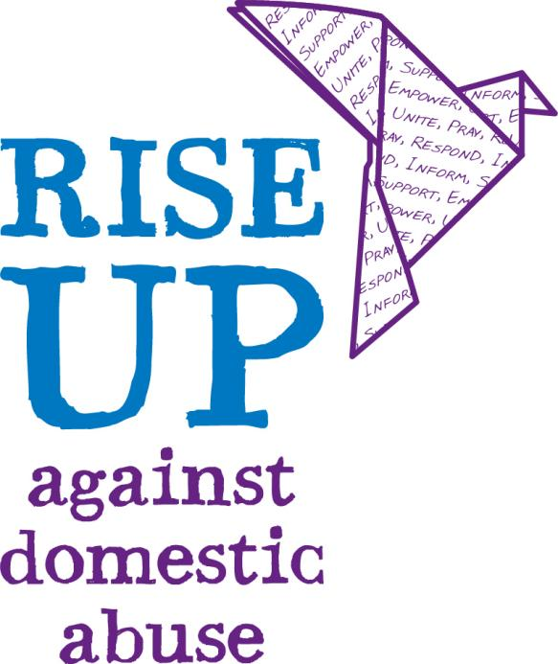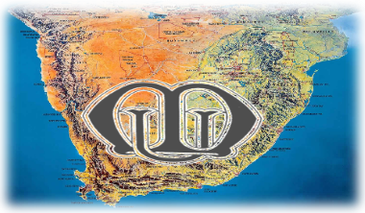

MU THEME 2025-2027:
JOIN US AND JOIN IN MU IS CHANGING LIVES
I WILL PRAISE YOU AS LONG AS ILIVE, AND IN YOUR NAME I WILL LIFT UP MY HANDS, I WILL BE SATISFIED AS WITH RICHEST OF FOODS WITH SINGING LIPSMY MOUTH WILL PRAISE YOU.
MESSAGE FROM THE LIASING BISHOP
As we start our year with the Theme “Join us, Join, Mothers Union is changing lives” we embrace the prayer diary, which is important for us. As we call others to join us, to join in, this will only be seen when we realise that prayer has changed us. The Mothers Union is about prayer. Paul in Colossians 42 says, “Devote yourselves to prayer, being alert/watchful and with thanksgiving. This is a timely reminder that we must pay attention to those things that keep us focused on God. Prayer is not an elective in the Christian’s life, but functions to keep us before God in a disciplined and attentive way. That is why we have a prayer diary, so that we must pray, every day. This is an accountability partner for our daily prayer life. We start by acknowledging God, declaring His sovereignty. Then we pray for the little things and watch God answer in loving ways. Not always for our good. Every time God answers a prayer, our faith in Him grows. When others see that we are people of prayer and we are growing in faith, transforming for the better though, they will join us, join and together we will transform lives.
So let us pray with boldness this year and I urge that you be women who are quick to notice God’s presence all around you. Be women who pray in Power, each time you approach the Lord in prayer, you bring each other to the feet of Jesus.
I therefore commend this prayer Diary to all.
God hears our prayers, no matter how simple or eloquent.
Revd (Liaising Bishop)
MESSAGE FROM PROVINCIAL PRESIDENT:
Beloved Sisters and brothers in Christ as we start the year 2025 we thank God for us in 2024. As we start this year let, we pray for God’s Grace and mercy upon us all .Pray for His spiritual guidance in all we plan to do in his service.
Let us pray that God guide our steps renew our strength and vision like that of an eagle .That the Lord be the wind under our wings and make soar to new heights as we serve through the Mothers Union ministry.
Without ceasing let, us pray for His omnipresence in every situation that we find ourselves in our homes, communities, workplaces and in pour families.
Let us strive to do what is just and pleasing to Gods eyes .As Mother Theresa said,” If anyone would sweep their own doorstep the whole world will be clean “
Let us therefore pray that God work through us to strive for excellence in our current roles, and be fully responsive to the needs of the people.
May God walk with us, may his hand guide us and may his grace sustain us through all
MESSAGE FROM THE PROVINCIAL PRAYER CO-ORDINATOR:
Dear Pexco and Diocesan Presidents:
We as the mothers Union members are united through the power of prayer .Prayer is our foundation ,our strength, and our inspiration .Each day at midday Mothers Union members all over the world pause to pray .The monthly themes in this prayer diary are echoed in our midday prayers .
Thy Kingdom come (Light up the world in Prayer) is the worldwide ecumenical prayer movement of Thy Kingdom come happens each year between Ascension Day and Pentecost Sunday.
MU members have been members of this call to prayer since its inception and once again, we come together as a movement to pray, “Thy Kingdom come”. It is hoped that everyone that takes part will
- Deepen the relationship with Christ
- Pray for five friends or family to come to faith in Jesus
- Pray for the empowerment of the spirit that we would be effective in our witness .(Galatians 2:20)
“So that it is no longer I who live but it is Christ who lives in me. A life that I live now, I live by faith in the Son of God, who loved me and gave his life for me “
HOW TO USE THIS DIARY:
Mothers Union at the at the diocese is a ministry that is Christ centred and prayer-based Partner with us as we bring before the Lord the needs of the Mothers Union community both locally and globally
Daily noon Prayers: Form the core of the Mothers Union work
Mothers Union Prayer: (Page 6 from MU Service book)
Start or end each time of intercession with Mothers Union Prayer, setting our hearts and minds on God and his work before focusing on individual needs
The Marriage & Family Life:
Heavenly father we thank that you ordained marriage and family life, modelled on relationship of Christ and the Church. We grieve as we see marriage devalued in the life of our nation. Please draw our people back to yourself and your word Mission prayers ACSA:
Lord of the harvest we ask that you lead and bless everyone currently involved in missions around the world. May their efforts help many others understand your grace and love. We pray that you will continue using the n missions to alter lives and bring about positive change worldwide. Through Jesus Christ our Lord.
Midday Prayer: (Page 13 from MU service book)
Pray a form of Midday Prayers. During these refer to these two parts prayer points by (me) Date and (ii) Wave of prayer.
Grant that the young people will be prepared to live in purity and that they will commit themselves to one another through public promises
MONTHLY PRAYER THEMES FOR CLUSTERS
January: Unity in Diversity: Aqua Cluster
Febrary: Membership: Aqua Cluster
March: The power of love through Christ: Eastern Cape Cluster
April: Love Blooms: Eastern Cape Cluster
May: Thy Kingdom Come: Nguni Cluster
June: Supporting our clergy: Nguni Cluster
July: Refreshment and Enrichment: Leica Cluster
August: MU at prayer (based on Mary Sumner prayer): Leica Cluster
September: Power of Reconciliation: Gauteng Cluster
October: Rays of Kingdom: Gauteng Cluster:
November: Spreading our Wings: All Clusters
Each month in the diary begins with a theme. There is also a bible verse related to the theme. Monthly prayers can be used as a resource at your Dioceses. There will be specific activities we need to pray for monthly. Each Cluster is allocated a monthly theme.
Can I request your prayer Points by end January form all clusters. Aqua Cluster you will combine your prayer points for February month.
Remember Midday Prayers and MU prayers form part of our daily intercessions as well as the wave of prayer
JANUARY 2025: Unity in Diversity:
REFLECTION:
1Corinthians1:10 (Let there be no divisions in the church rather be of one mind united in though and purpose).
In January, we celebrate the week of prayer for Christian unity. Very often is seen as working hard to be the same as everyone else. We are all unique, created that way by our heavenly Father. We all have different cultures and experiences and approach worship in different ways, but we worship same God who loves and died for us on the cross. As we begin a new year, with all that it will bring, let us be united in prayer and worship and step forth together in faith.
MONTHLY PRAYER:
Father grants us grace to dwell and grow in the knowledge of your love for all people and nations, and in all circumstances. We lift our voices in praise and thanks giving for the beautiful tapestry of diversity woven into fabric of unity in cultures, languages and traditions. We see your boundless creativity and love. Help us embrace diversity with open hearts, celebrating the unique gifts each individual brings. Men

FOCUS MONTHLY PRAYERS:
- Province, we pray for our Newly elected Provincial President, Deputy PP and the Presidents Rep Praying for wisdom and strength for MU leadership in order to ensure growth of the organisation
- PEXCO and Diocesan Executive meetings
- St Agnes Commemoration Day at all Dioceses

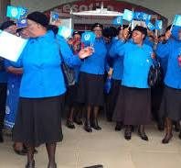
United in prayer

WAVE OF PRAYER: See Addendum

FEBRUARY 2025: Membership (Isiah 41:10)

REFLECTION:

“” Do not be afraid, for Gawith you. Don’t be discouraged, for I am your God. I will strengthen”
May we bloom where we are planted?
As we take a moment to think of the impact that we have around the world as Mothers Union., may we remember the lives that are touched daily, at lours of the day when we pray for one another. God has planted each one of us where we need to be. He has laced us here in his time and in his way. As we are scattered, as seeds in our communities. We are part of the new growth through the resurrection power of Christ and through the strength of the Holy Spirit. We are a people of hope. Let’s reflect this unshakable hope together as Mothers Union.

MONTHLY PRAYER:
We give thanks to you. Lord for our membership in the global Mothers Union. May we be blessed with a sense of connection and belonging. May we accept the call in the power of the Holy Spirit to grow in faith? May we be empowered in all that we do and say to help others. May we bloom where you plant so Lord. Amen

FOCUS PRAYERS:
- Provincial Itenery Provincial office and staff
- Mothers Union activities at all Dioceses
- Pexco training Diocesan Presidents on the13.02.25-16.

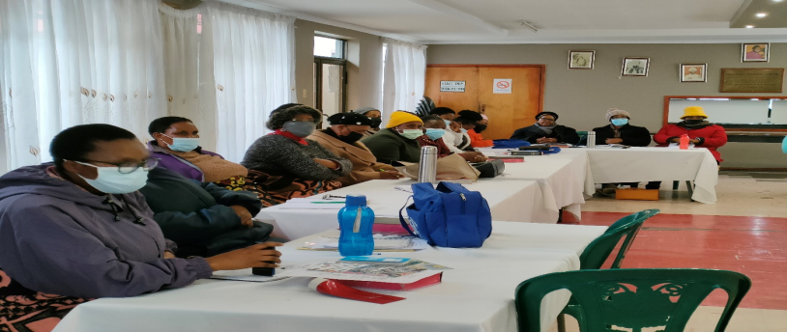

WAVE OF PRAYER: See Addendum

MARCH 2025: PSALM 33: 22 THE POWER OF LOVE:

REFLECTION
” MAY YOUR UNFAILING LOVE BE WITH US, LORD, EVEN AS WE PUT OUR HOPE IN YOU”

March in many ways, a month for women as we mark International Women’s Day and mothering Sunday. Women once were deemed weaker sex, yet so often they have an abundance of Power and strength inherent in their very beings. Simply because of love Women are also tender, gentle, nurturing but in one of the world’s great dichotomies, they are also strong, tenacious, and courageous. Whoever the moment arises. Women are at fore front of calling to protect the innocent, defend the helpless and to stand resolute against injustice
MONTHLY PRAYER:
Father, we thank you that through the sacrificial love of Christ we have been shown the transcending and transforming power of love. Thank you for the unending grace and redemption found in his sacrifice. Thank you for his selfless sacrifice, which exemplifies the depth of your, love for us. May we reflect his love in all we do. Help us to be people showing love for others through inclusion, forgiveness, compassion and social justice. In your holy name we pray Amen. (Based on 1 John 4verses 7-12
FOCUS PRAYERS
Let us pray for our link Dioceses
- Womens World Day of Prayer
- Mothering Sunday at all Dioceses
- Lady Day celebrations
- World TB Day
- Lord, we pray for all Dioceses and their links

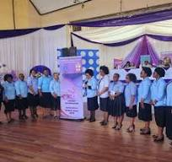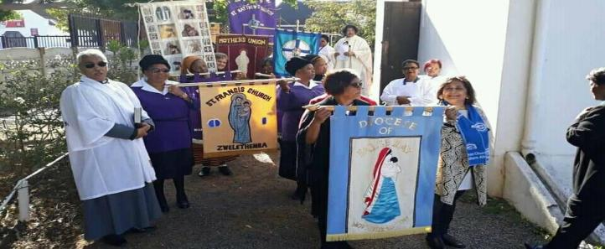
Cluster Lady Day

WAVE OF PRAYER:

APRIL 2025: LOVE BLOOMS:

THE OPENING AND BLOSOMING OF FLOWERS AND TRESSSYMBOLIZES RENEWAL, GROWTH AND TRANSFORMATION

April month was the second month in Early Roman calendar but became fourth when the ancient Romans started using January as the first month. April is named from the Greek goddess of love Aphrodite. The name for the month of April original came from
REFLECTION:
Love blooms all around us this month. We begin to see Gods goodness as creation starts to bloom. Then as we approach Easter, we prepare our hearts to see God solve blooming from the tomb in joyous resurrection. Both are a reminder of Gods extraordinary love, and serve as a call to action, to pass on both the planet, and the Gospel message for generations to come.

MONTHLY PRAYER:
Lord, I light the candle as a symbol of love, I pray that the love you send me will be strong like a flame. May it blossom and radiate your love that blossoms in all. Heavenly father we come before you with hearts of gratitude and praise for the wondrous way love blooms in our lives. In the gentle whispers of kindness, in them warmth of fellowship, and in the selfless acts of service, we see your love reflected. May we be the vessels of your love, spreading kindness and compassion whenever we go. Amen

FOCUS PRAYERS:
- Christian’s celebration of resurrection of Jesus Christ
- Lady day celebrations at some dioceses
- World Autism Day
- April fool’s day
- World health day
- Diversity Month
- National Garden month day
The women who had come with Jesus from Galilee followed Joseph and saw the tomb and how his body was laid in it. Then they went home and prepared spices and perfumes (Luke 23:55-56)

WAVE OF PRAYER: See Addendum

MAY 2025: THY KINGDOM COME:

REFLECTION:
The central motif of all Jesus teaching was the Kingdom of God, the rule and reign of God on the Earth. Jesus doesn’t just announce the Kingdom of God in him the Kingdom of God arrives.
But while the Kingdom has begun It is not fully here-Gods world is still characterized by pain, injustice, and death.
Top pray the words “Thy Kingdom Come” is to express a desire and a hope for the world to be better place.
A world where lives, relationships and communities can have life and life to the full through faith in Jesus.

Think ahead to our 16 days of Activism and plans by sharing stories

MONTHLY PRAYER:
Lord as we gather in prayer across the we word we remember your plan of salvation where there are no barriers to hear the good news of Jesus Christ. Come Holy Spirit as we pray
“Thy Kingdom Come “. Father, we pray that it will bring us closer within our worldwide family of Mothers Union so that Thy Kingdom Come resounds around the corner and around the world. Amen

FOCUS PRAYERS:
- 12 May2025: International nurses’ day of prayer with candle lighting
- 13 May 2025: Diocesan MU Council at all Dioceses
- Mental Health awareness
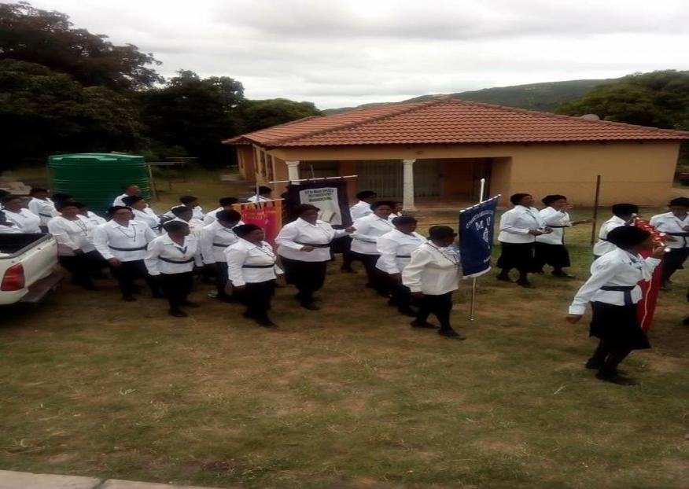
Faith in Action

WAVE OF PRAYER: See Addendum

JUNE 2025 SUPPORTING OUR CLERGY:
REFLECTION:
In the much -loved prayer used by our founder, Mary Sumner, she prays All this day, O Lord let me touch as many lives as possible for thee. As we consider our own faith journey. It is good to reflect on people who have touched our lives for Christ. Consider how your life has been touched by friends, family, Mothers Union members past and present, and our clergy. Consider how you may have touched lives for Christ, through words or actions or just being you.
MONTHLY PRAYER:
Gracious God ,we offer heart felt praise and gratitude for the privilege of supporting our clergy .Bless them with Wisdom, strength ,and compassion as they help their communities .May our encouragement be a source of strength to them in times of need .Thank you for their dedication and sacrifice in serving your people .Guide us to uplift and uphold them in prayer and practical assistance .In your holy name .Amen

FOCUS PRAYERS:
- 16 June: Youth Day
- World environmental day
- International yoga day
- Dioceses that are organizing conferences in 2025
- World Environment – Global Warming
- Election of Parish leaders at all Dioceses

WAVE OF PRAYER: See Addendum

JULY 2025: REFERSHMENT AND ENRICHMENT:
REFLECTION:
This July we consider families and the Away remittal schemes that provide a vital break for those facing challenges. Holidays are important, as a way to recover from the busyness of urn lives and to spend time with those we love. But we don’t have to travel far to follow the long Christian tradition of pilgrimage. Committing to undertake a sacred journey to meet with God is allowing ourselves to be refreshed and enriched by him. May we use this July to find ways to rest in the Lord.to reflect on experiences of his amazing grace and allow ourselves to be restored
MONTHLY PRAYER:
As we move in a month when many of us take a break from the regular routine of life, we pray that we will find sacred moments of rest and reflection, of refreshments for our weary souls. Thank you for the opportunity to pause, to breathe, and to be rejuvenated in your presence. As we journey through these days of respite, may our spirits be enriched by the beauty of your creation, the warmth of fellowship, and the joy of your love. Guide us to use this time wisely, to grow closer to you intone another in your holy name Amen.

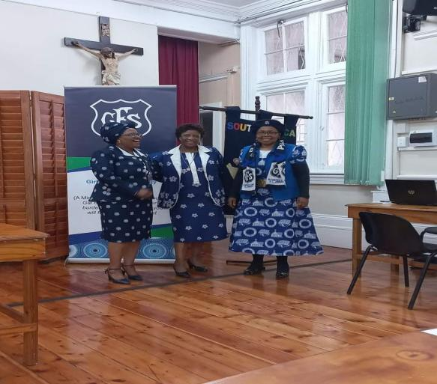
Sowing the future together

WAVE OF PRAYER: Refer Addendum

AUGUST 2025: MU AT PRAYER (BASED AT MARY SUMNER PRAYER)
REFLECTION:
Mary Sumner day is on the 9th of August, leaving us with a model to follow, exemplified in her prayer. All this day oh Lord, let me touch as many lives as possible for thousand every life I touch, do thou by thy spirit quicken, whether through the word I speak, the prayer I breathe or the life I live. Amen
Mothers Union began with small seed of Mary Sumners vision and obedience to God, nearly one hundred and fifty-five years later we have grown into the huge international organization that is Mothers Union today.
Let each one of us follow Mary Summers lead and support one another in prayer and action. As we implement the theme Join Us, Join in

MONTHLY PRAYER:
As we move into a month when many of us take a break from regular routine of life, we pray that we will find sacred moments of rest and reflection, of refreshment for our weary souls. Thank you for the opportunity to pause, to breathe, and to be rejuvenated in your presence. As we journey through these days of respite, may the beauty of your creation, the warmth of fellowship, and the joy of your love enrich our spirits? Guide us to use this time wisely, to grow closer to you and to one another. In your holy Name. Amen
FOCUS PRAYERS:
- 09.08.25 Celebrating Mary Sumner at all Dioceses
- World Wide Women’s Day of prayer
- Prayer for all 25 Dioceses of Southern Africa with Mothers Union Guild

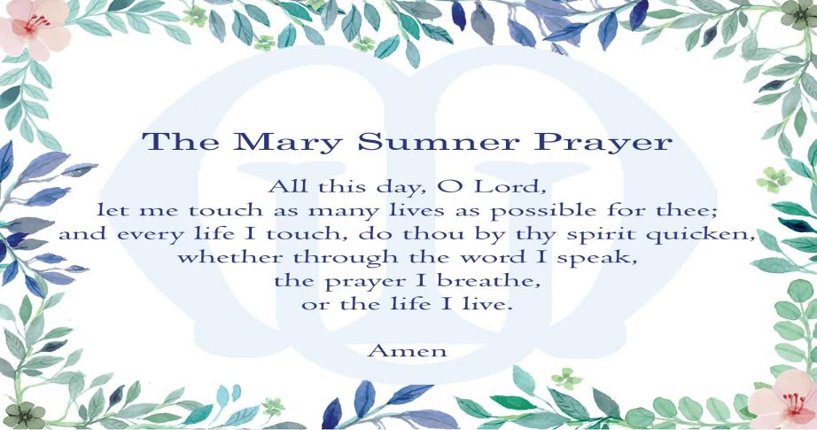

WAVE OF PRAYER: See Addendum

SEPTEMBER 2025: POWER OF RECONCILIATION:
REFLECTION:
Sometimes it seems that our troubled world is in immersed in the pain and suffering conflict and broken relationships .Yet Jesus reminds us that even though we are all less than perfect ,Every one of us is worthy of being redeemed ,loved and forgiven .As members of the Mothers Union ,we are 09: Women’s Day Service/ Mary Sumner Day building a future of reconciliation ,justice and peace in partnership with the community of the cross of the Nails
MONTHLY PRAYER:
Father as we seek to follow your son, help us to be always aware of how our actions and words affect others and the world around us. Give us grace to be peace makers among people and good stewards of your creation.
FOCUS PRAYERS:
24th: Heritage Day celebrations at all Dioceses
May the Holy Spirit embrace members of Mbhashe Diocese? Grant them peace, love and happiness in their efforts to develop work of the Mothers’ Union.
ALBINISM AWARENESS MONTH FOCUS AT ALL DIOCESES

WAVE OF PRAYER:

OCTOBER 2025:
Reflection:
During a World Day of Prayer service ,we are requested to look at our house key, and ask “What does it say to you “.The most frequent response was scrutiny and safety as well as a scattering of home ,love and peace .One person wrote “Keys of Kingdom “ for ourselves and for others, especially people who have no place of safety and for the improved body ,mind and spirit .
MONTHLY PRAYER:
The spirit of the Lord is on me, because he has anointed me to proclaim the good news to the poor. He has sent me to proclaim freedom for the prisoners and the recovery of sight for the blind, to set the oppressed free, to proclaim the year of the lord’s favour (Luke 4 verses 18-19). As we focus on Prison ministry, we pray that we too would respond to Jesus’ call. We give thanks for the mothers Union members who support Prisoners their families.

FOCUS PRAYERS:
- Clergy Prayer and appreciation days at all Dioceses
- Father gives our Bishop, Priests and Deacons inner strength to teach us guide and lead with the Power of the Holy Spirit.
- 4-16 Diocese of Mthatha in South Africa links are: Namirembe in Uganda, Pankshin & Sabongidda-Ora in Nigeria, Dublin &Glenda lough in all Ireland and central Solomon’s Islands
HEALTH AWARENESS: BREAST CANCER AWARENESS MONTH AT ALL DIOCESES

WAVE OF PRAYER: See Addendum

NOVEMBER 2024: WOMENS EQUALITY AND EMPOWERMENT
REFLECTION:
During November the nights are long and cold .We start to look towards Advent and as members of Mothers Union ,We also look towards the 16m days of Activism Against Gender -Based Violence .In a season when we want Tube warm and cosy ,let us remember that we need to spread our wings and RISE UP to speak about domestic abuse .We know how powerful and far reaching the Rise Up campaign has been Solet spray this month that our witness can help grow our membership and also in turn grow the Kingdom of God

MONTHLY PRAYER:
Those who hope in the Lord Will renew their strength. They will soar on wings like eagles, they will run and not grow weary, they will walk and not be faint (Isaiah 40verse 31)
Restore our faith in your eternal purposes, renew in us the hope that never fails, lift our eyes to the things that are unseen and eternal, that we may discern and embrace the new things that you have prepared for us in Christs name .Amen.
FOCUS PRAYERS:
04-05: AGM Dioceses
27- 30: 16 days of Activism start
Let us pray for a Divine intervention and Protection of all women and children who are victims of all kinds of abuse.

WAVE OF PRAYER:
DECEMBER 2024: Advent and Christmas:
Reflection:
As we enter the seasons of Advent and Christmas -let us think about invitations .December is such a time of preparations: invitations, messages and cards, feasts and parties, gifts and secrets, travel plans or bed making and welcoming. It may also be a time of repentance, deep sorrow and loneliness, frustrated hopes and, financial difficulties or for so many in our world, of hunger and fear. Let us prepare our hearts and minds to receive the greatest gift of Christ.
MONTHLY PRAYER:
Gracious God, we gladly accept and give thanks for your invitation to venture with you through this season of Advent. As we wait in anticipation the promises foretold bit the Prophets behold a virgin shall conceive and bear a son ,may we be ready at his birth ,to recognise the gift of your Son and be well prepared to love and serve him .Amen
FOCUS Prayers:
01.12.25 : World Aids Day at all Dioceses
Father God we bring before you all those who are infected and affected, broken, struggling to survive. Bring strength and hope in those who offer their love, support and care to the sufferers. Bless them always to sustain and rebuild families and communities.

WAVE OF PRAYER: Refer to addendum

Make me a channel of your peace :Where there is hatred ,let me bring your love ,where there is injury ,your healing power,and where theres doubt ,true faith in you

